**Create a lifecycle rule**

Click on Lifecycle in management pane of your S3 bucket

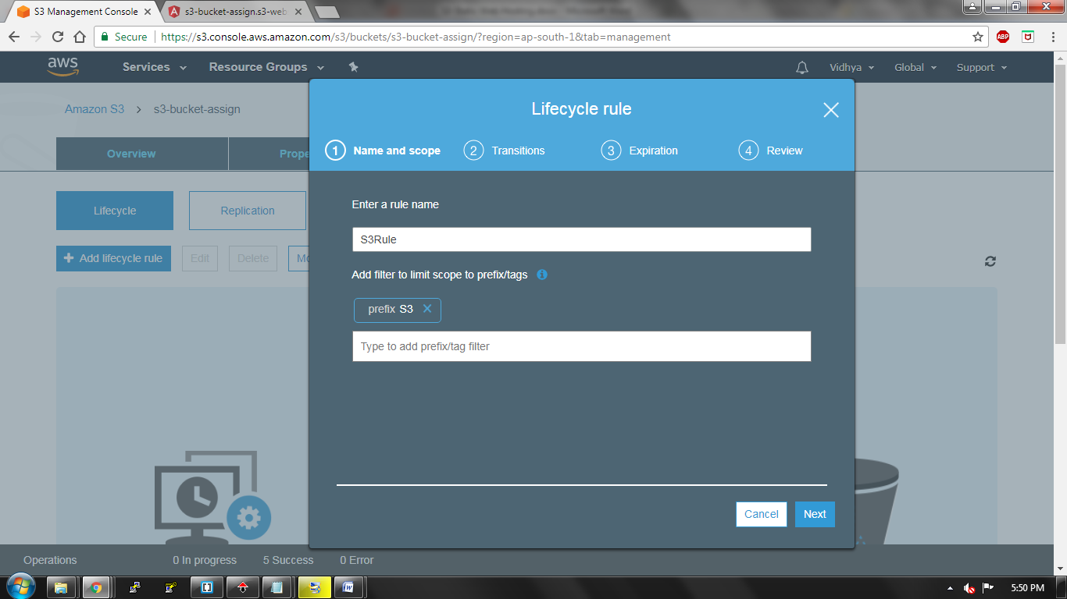

Configure your transition whether it is your current version or previous version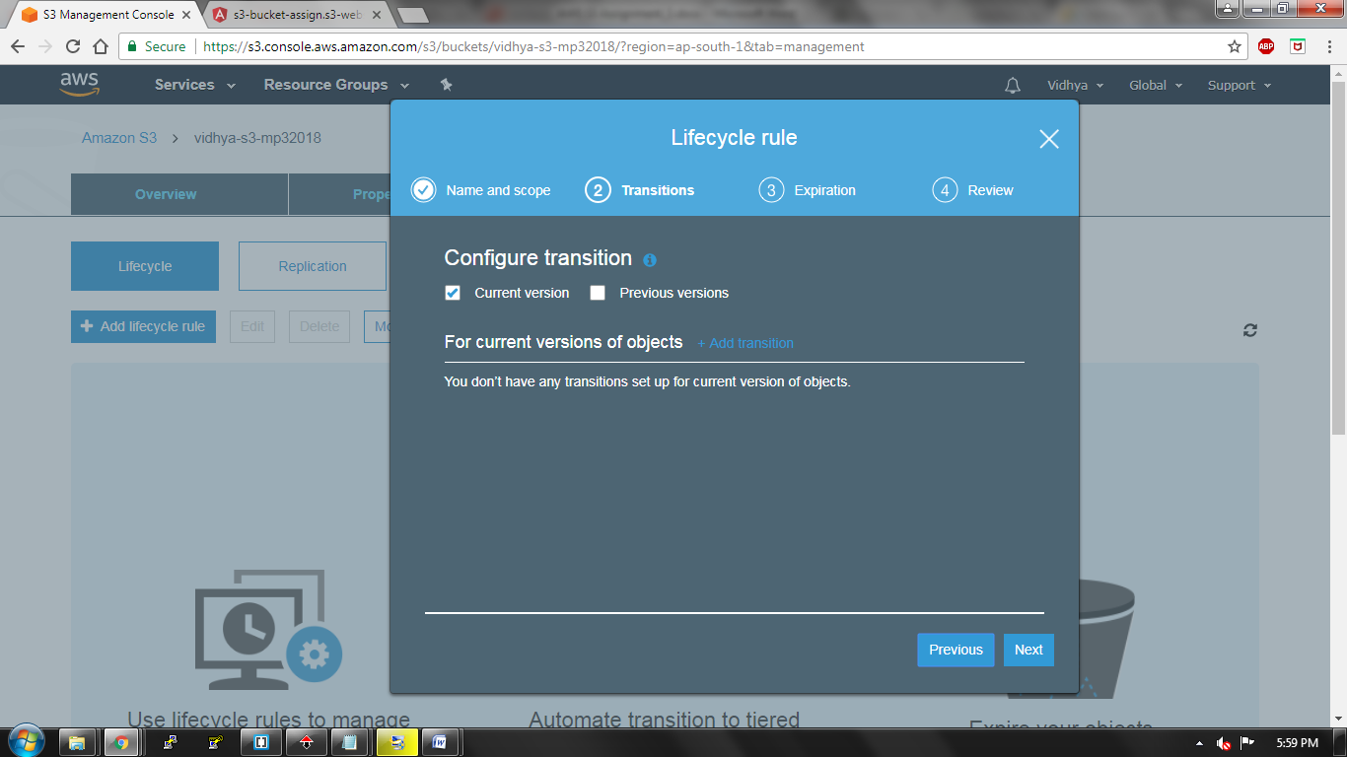

Add transition rule so that your data older than 45 days moves to Standard-IA and data older than 100days gets archived in glacier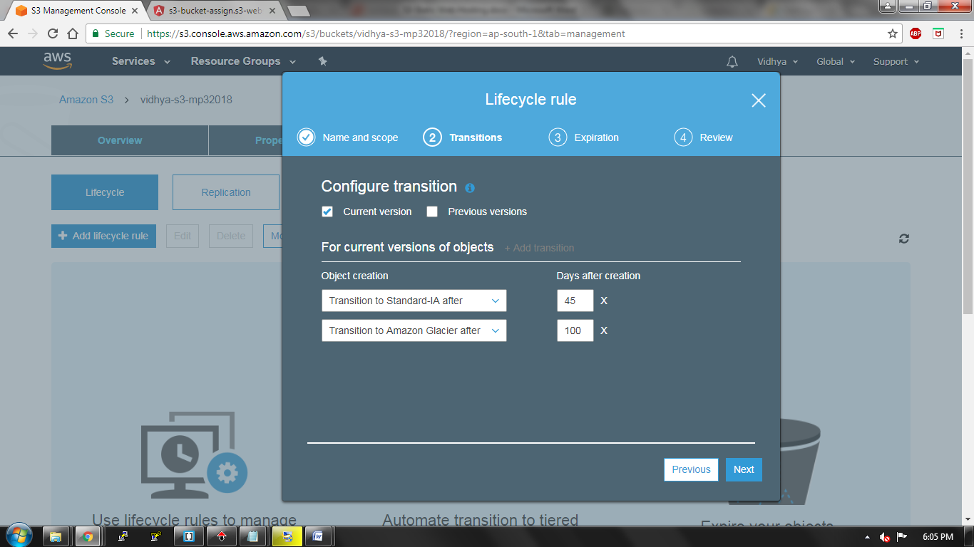

Clean up expired object, delete markers and incomplete multipart uploads after 7 days of upload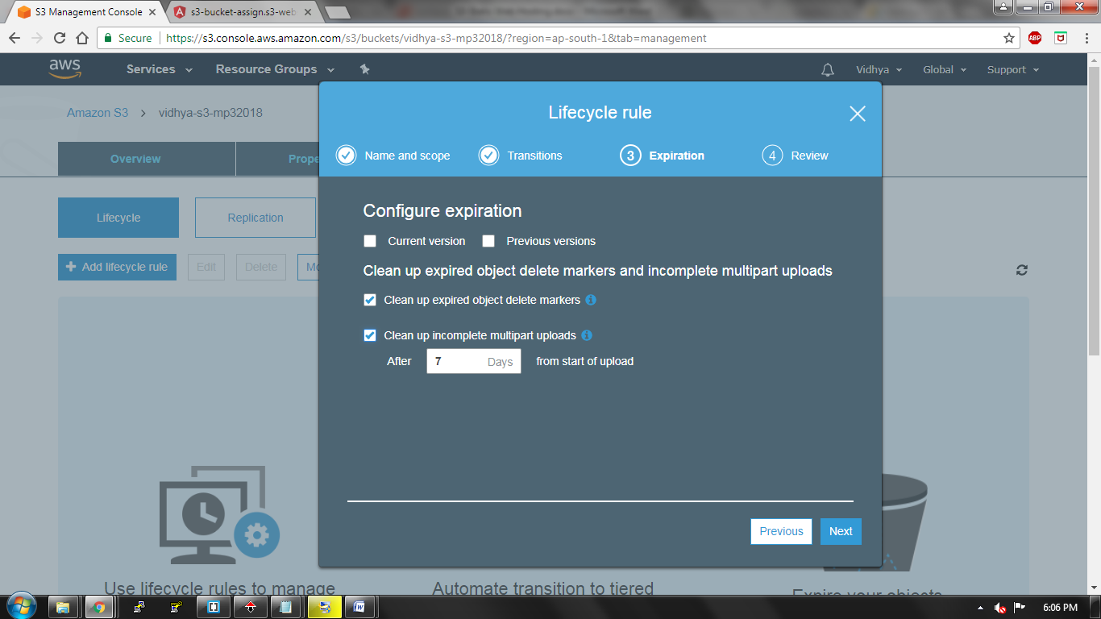

Review your lifecycle rules and save your changes